Software Quality Assurance (SQA) – 2nd Week Project Task
Name: Jaweria Kamran DHC (4521)

Project Title: Testing of Daraz Website

- PART 1: Compatibility Testing

1. Objective:
The purpose of compatibility testing was to verify that the Daraz website works properly across different web browsers and provides a consistent user experience.

2. Test Environment:
- Operating System: Windows 10
- Browsers Tested:
  - Google Chrome
  - Mozilla Firefox
  - Microsoft Edge

3. Features Tested:
The following features were tested on all browsers:
- Login
- Product Search
- Add to Cart
- Buttons
- Image loading
- Page Layout and Navigation

4. Test Results:
Feature | Chrome | Firefox | Edge | Status
Login | Working | Working | Working | Pass
ProductSearch | Working | Working | Working | Pass
Add to Cart | Working | Working | Working | Pass
Page Layout & Navigation | Proper | Proper | Proper | Pass
Image Loading | Proper | Proper | Proper | Pass
Button | Working | Working | Working | Pass

5. Compatibility Conclusion:
The website performed consistently across all tested browsers. No major compatibility issues were identified during testing.
- Microsoft edge
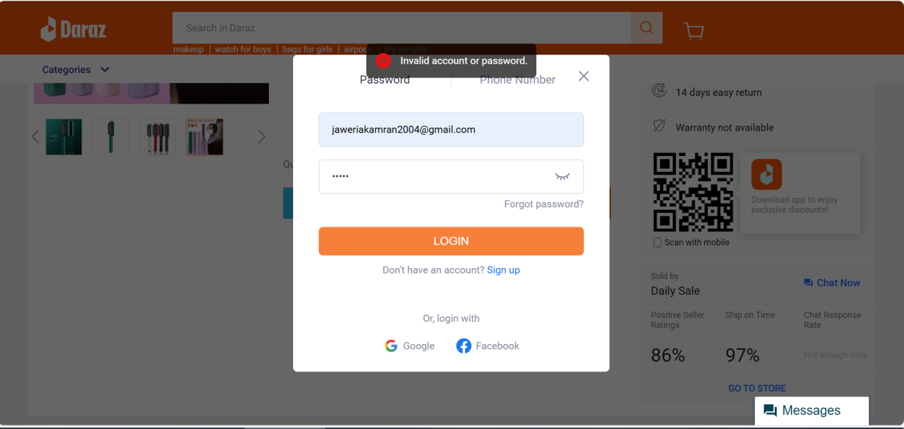
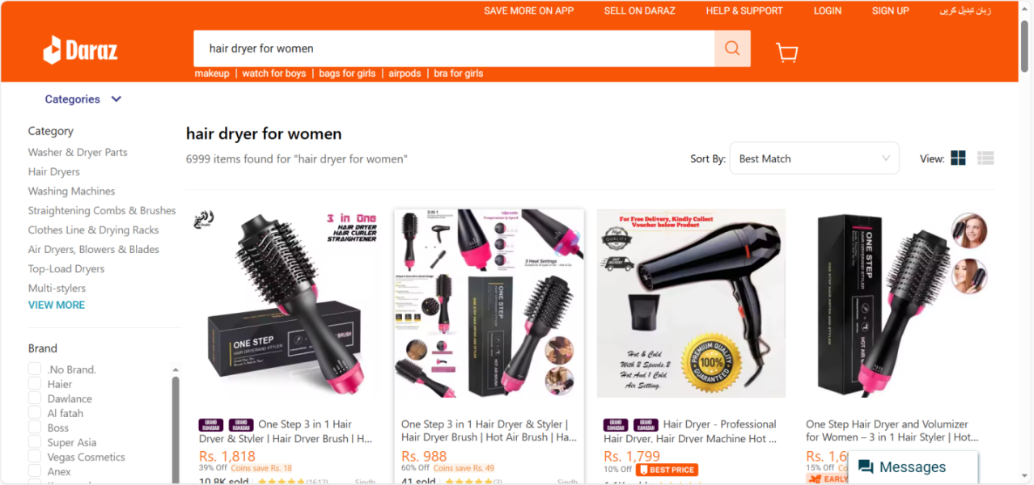
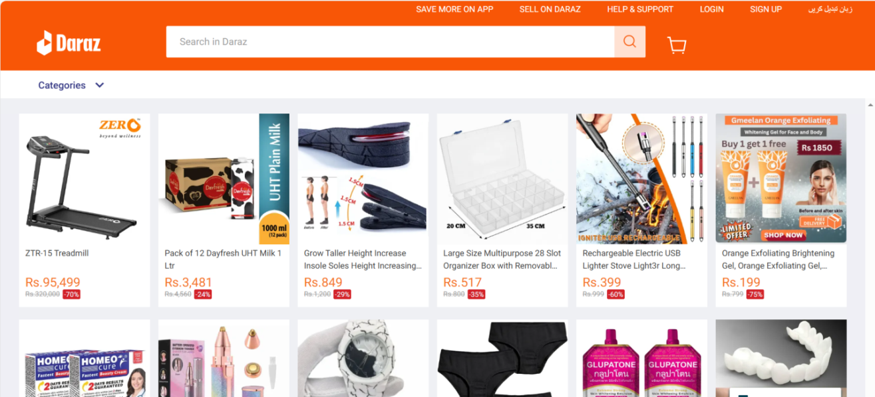
- Google Chrome
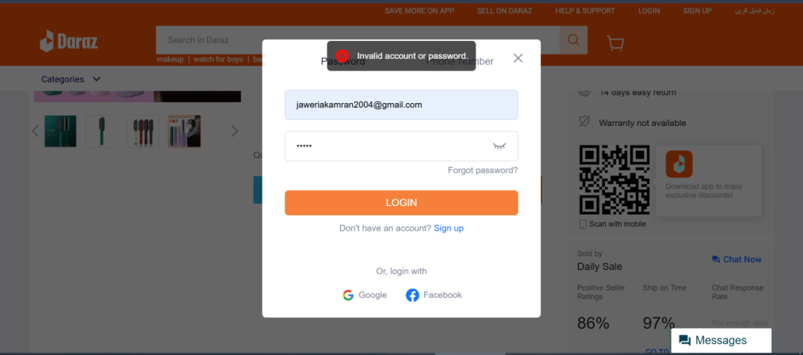
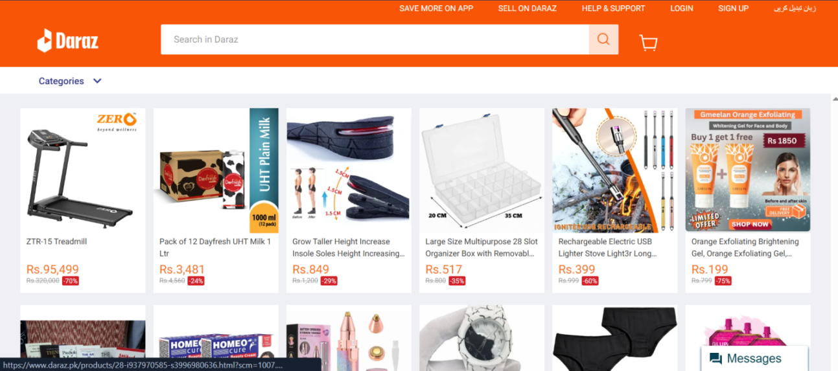
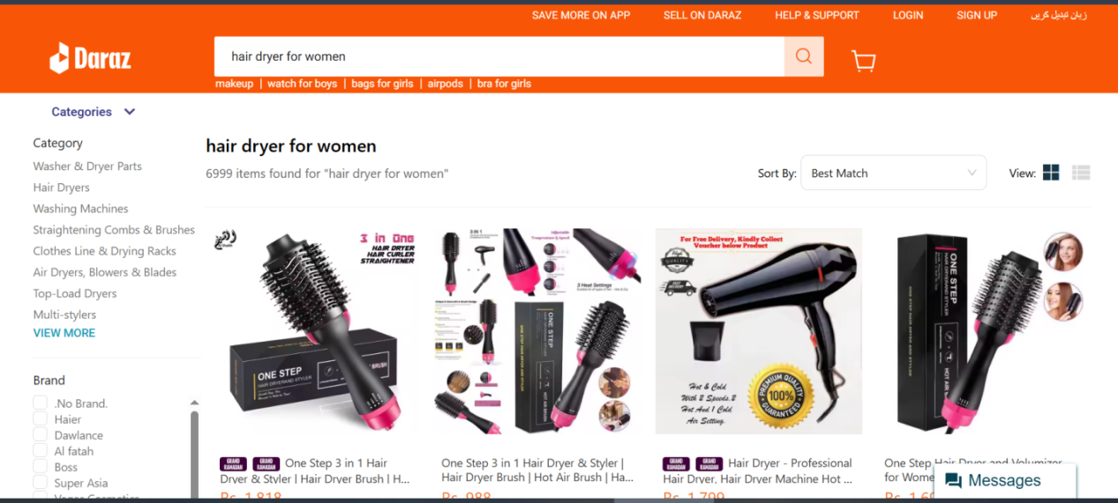
- Firefox
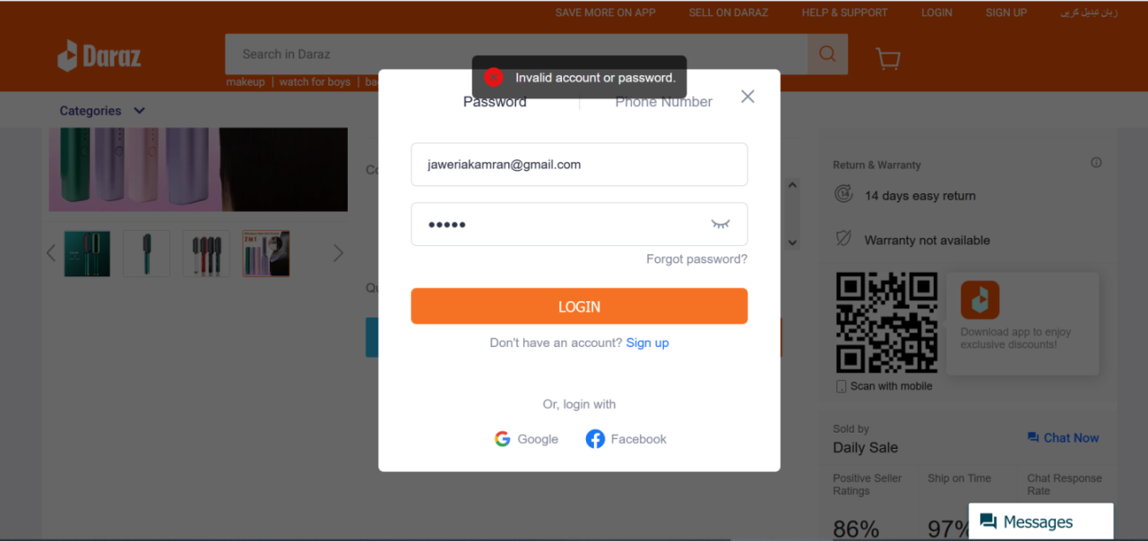
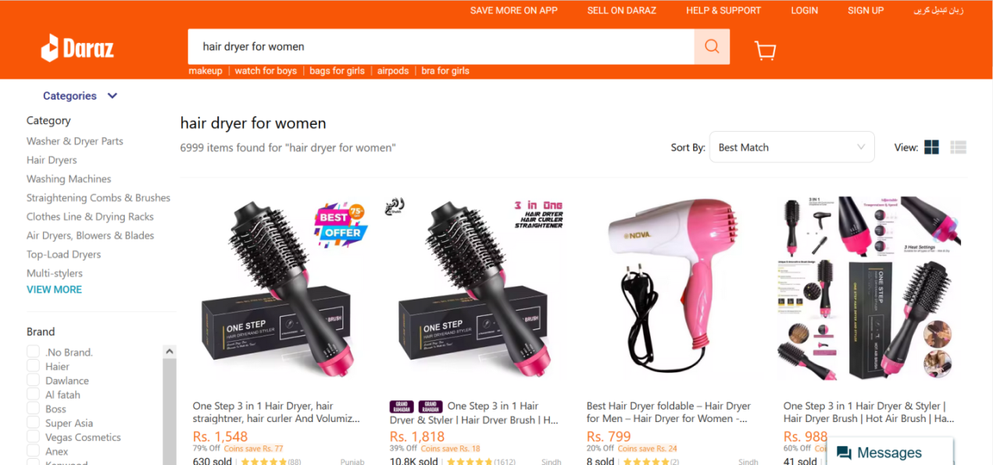
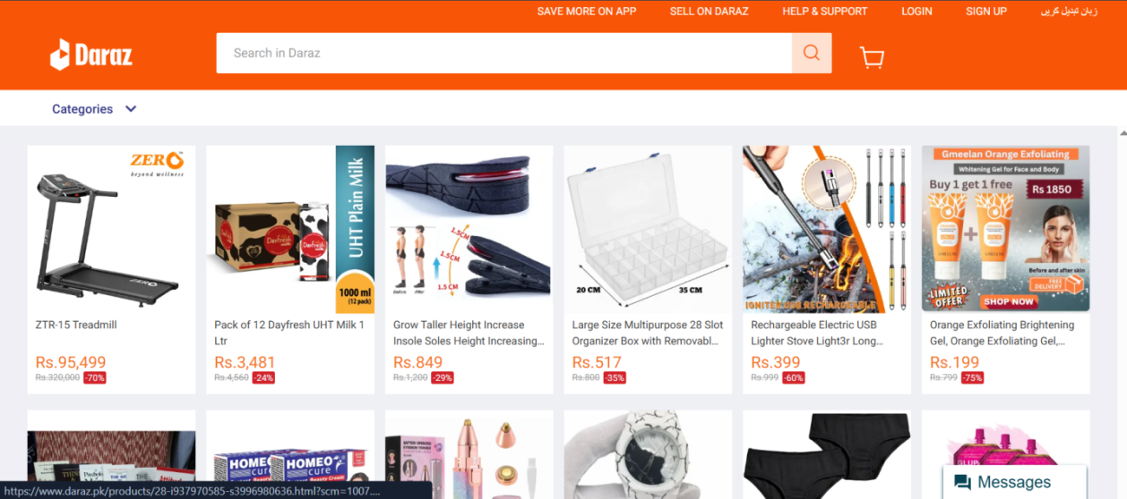

- PART 2: Retesting Report

1. Objective of Retesting:
Retesting was conducted to verify whether the previously reported defects from Week 1 were fixed.

2. Retesting Procedure:
Each previously reported bug was re-executed using the same steps that were used to reproduce it earlier. The system behavior was observed and compared with the expected result.
3. Retesting Results:
- EXCEL SHEET RESULT
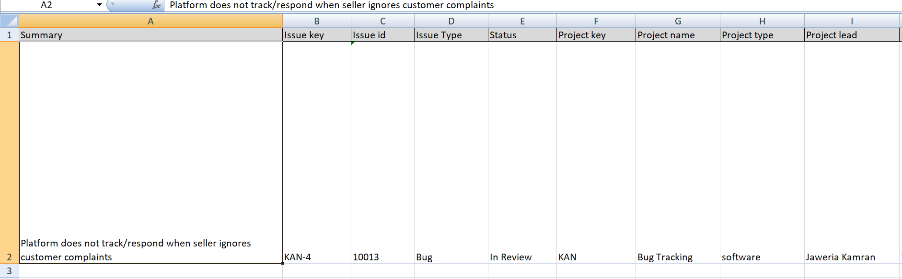
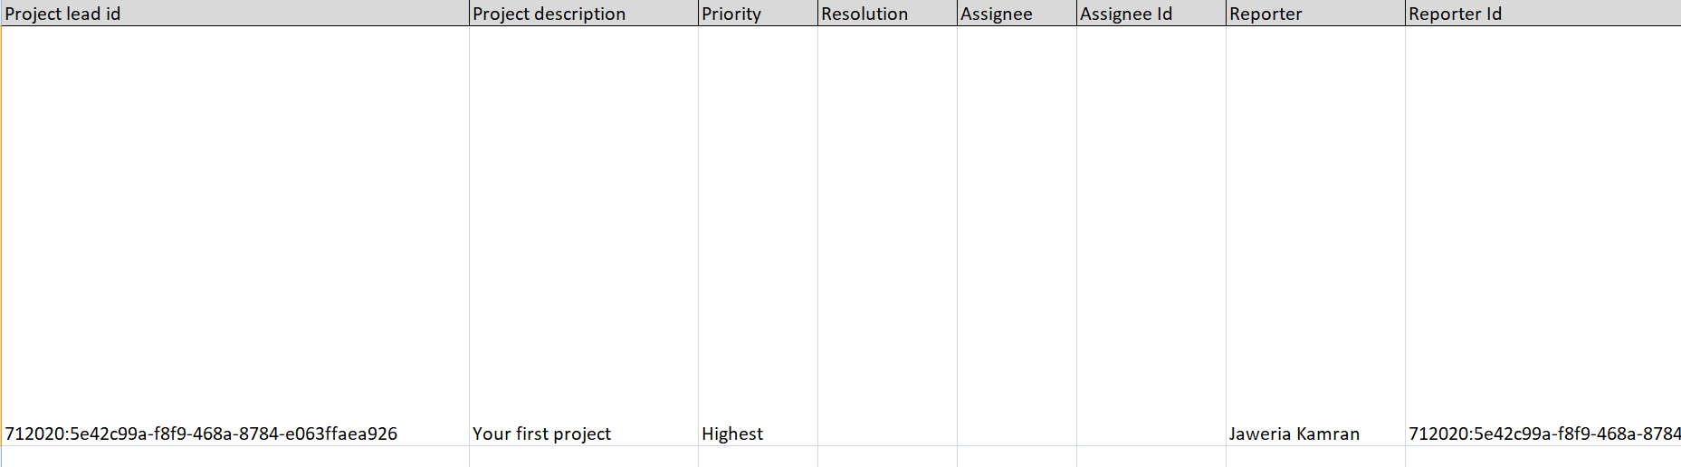
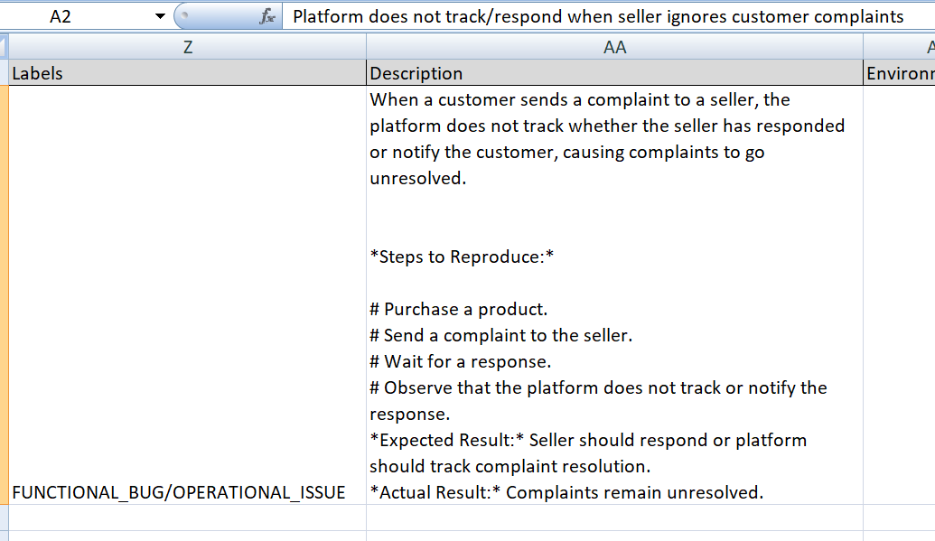
- WRITE TEST CASE ON JIRA TOOL
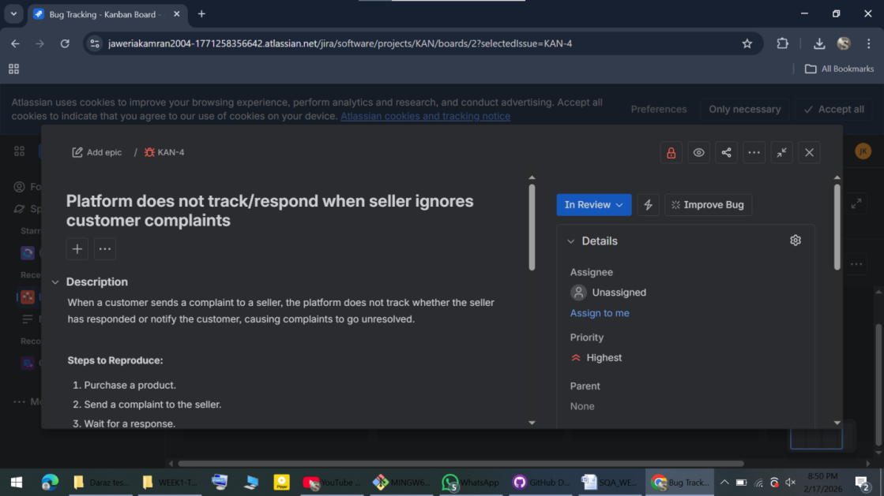
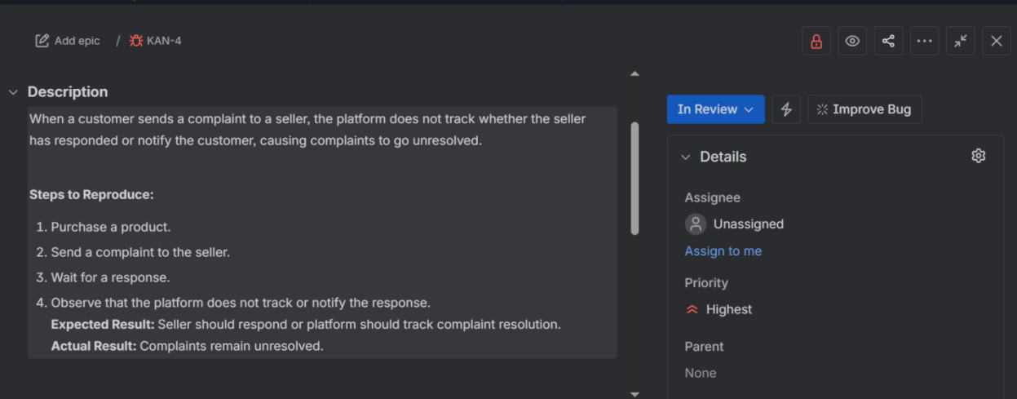
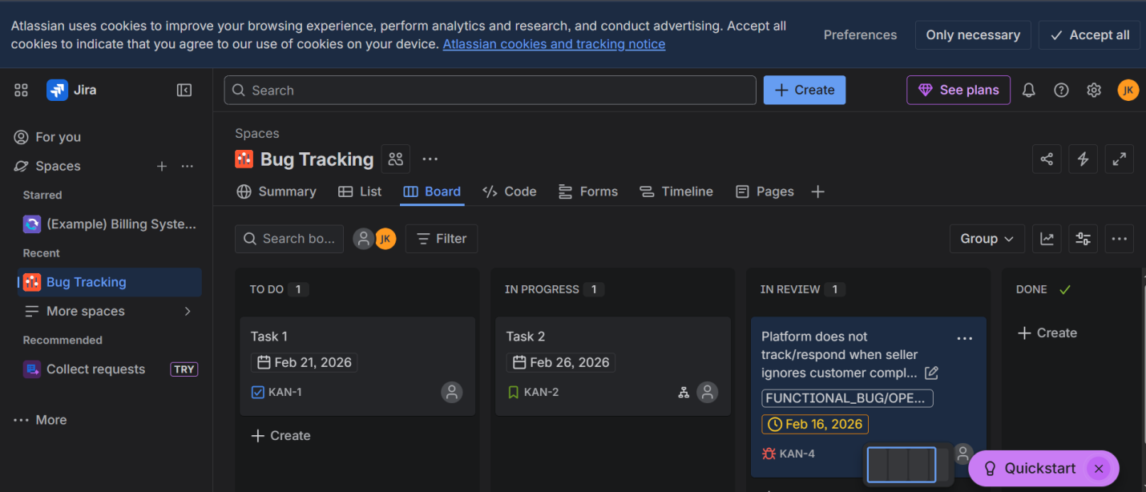
4. Retesting Conclusion:
During retesting, it was observed that the issue related to seller complaint tracking still exists. The platform does not notify or escalate unresolved complaints. Therefore, the defect remains unresolved and has been marked as Reopen.

